Table of Contents
Page
Representative Habitat Photographs at CRLF Survey Ponds 1
Ralston Ridge Pond 1
Representative Habitat Photographs at CRLF Survey Ponds 3
Horseshoe Bar Pond C 3
Representative Habitat Photographs at CRLF Survey Ponds 4
Horseshoe Bar Pond E 4
Representative Habitat Photographs at CRLF Survey Ponds 5
Horseshoe Bar Pond F 5

Representative Habitat Photographs at CRLF Survey Ponds

Ralston Ridge Pond
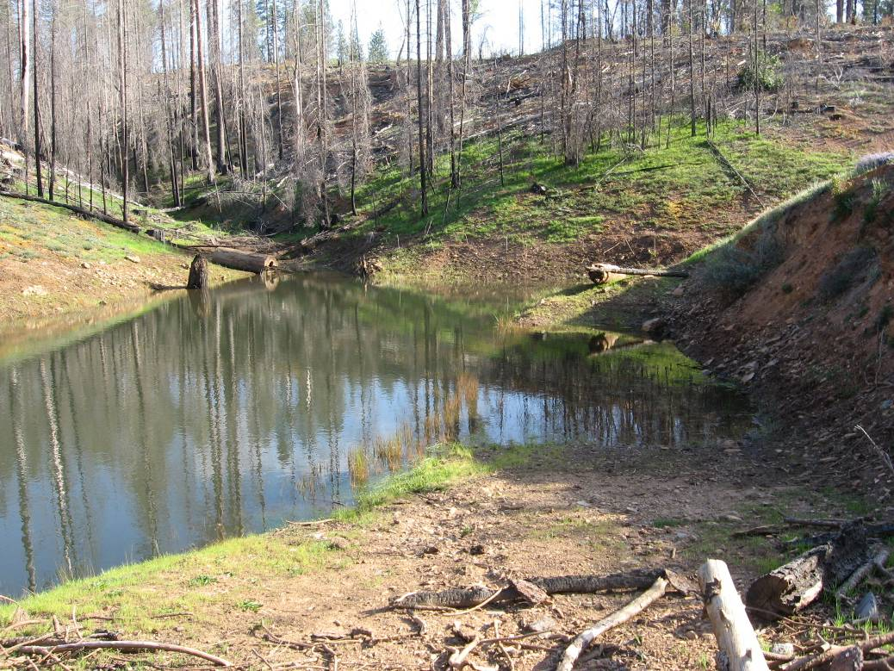
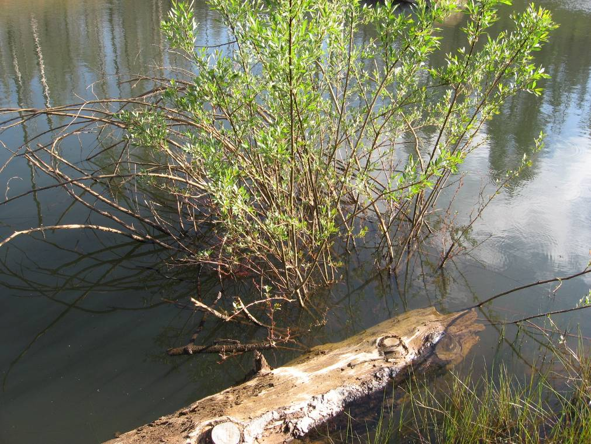

Representative Habitat Photographs at CRLF Survey Ponds

Ralston Ridge Pond
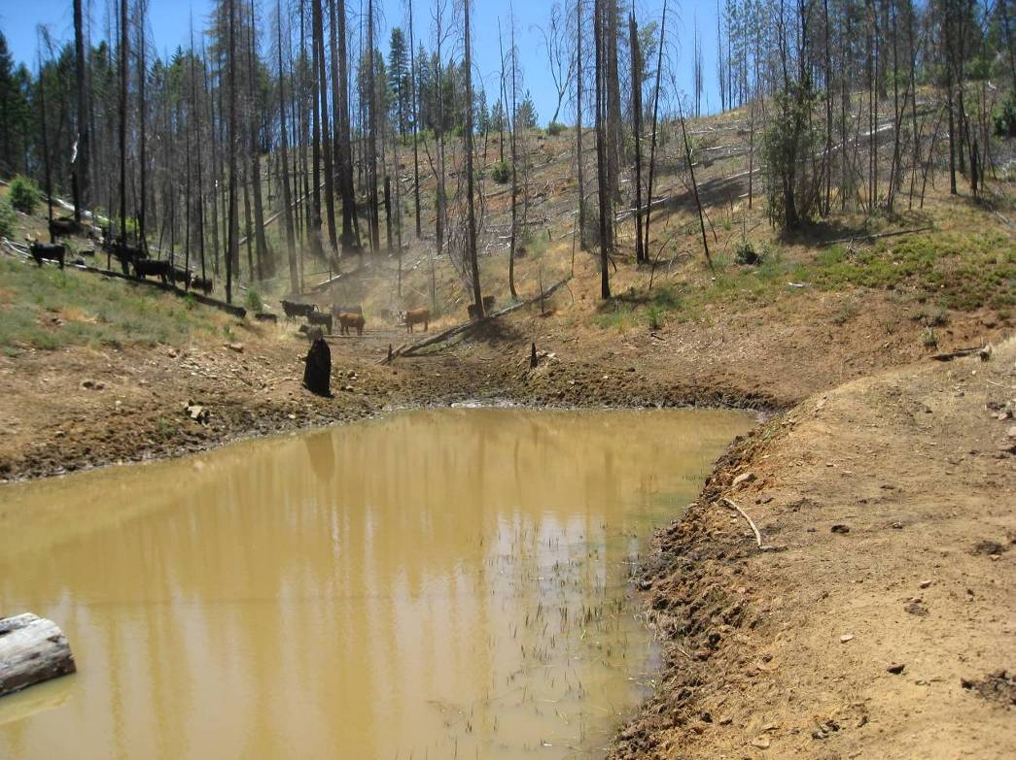

Representative Habitat Photographs at CRLF Survey Ponds

Horseshoe Bar Pond C
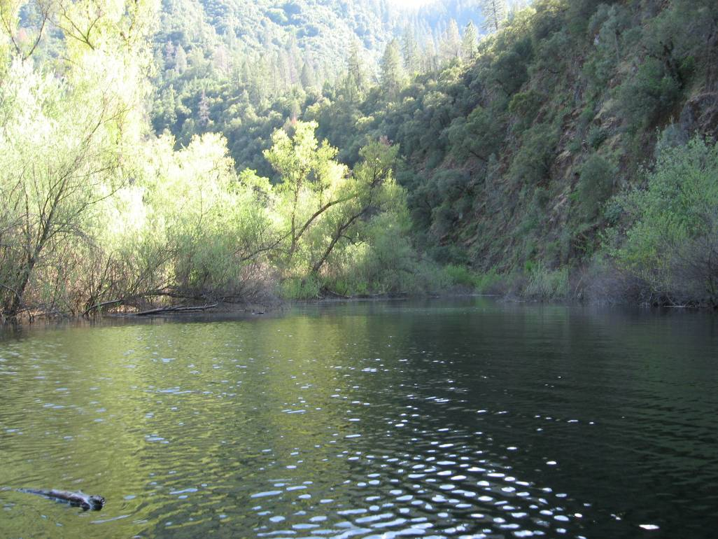
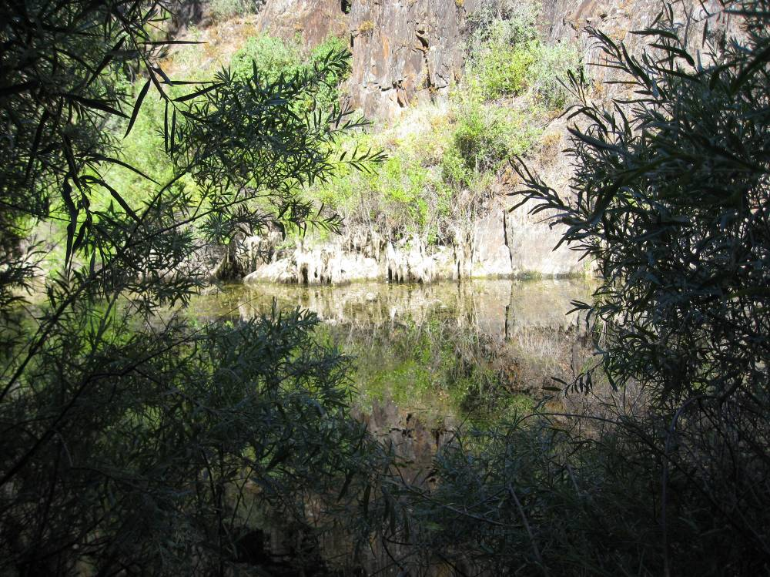

Representative Habitat Photographs at CRLF Survey Ponds

Horseshoe Bar Pond E
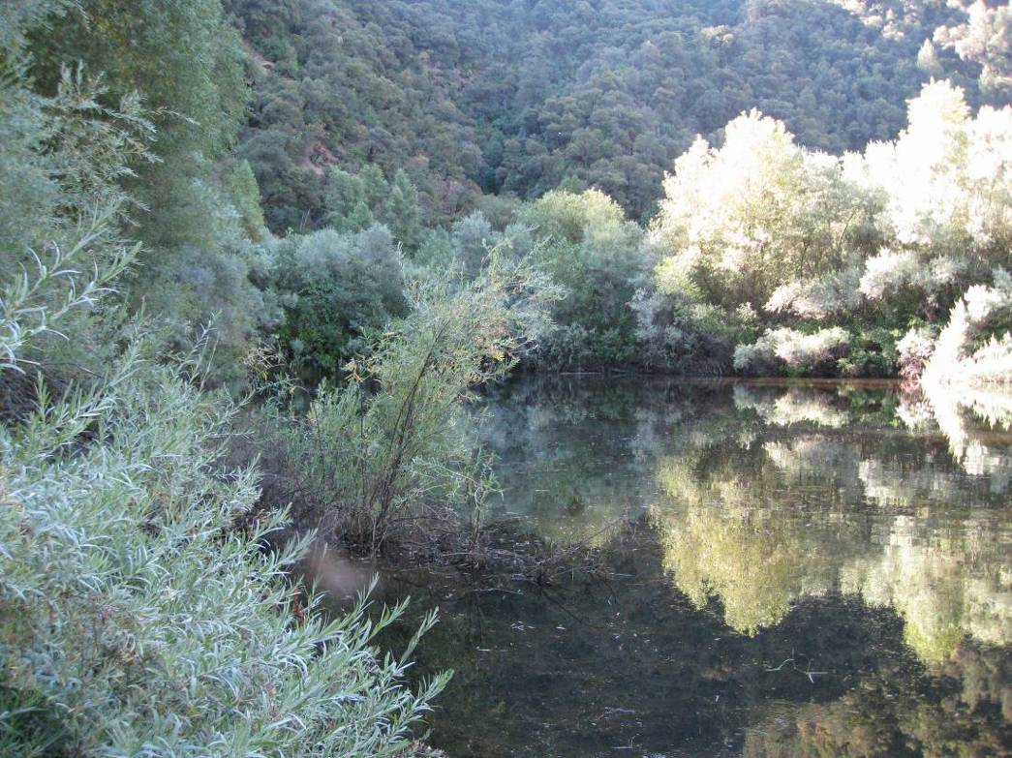
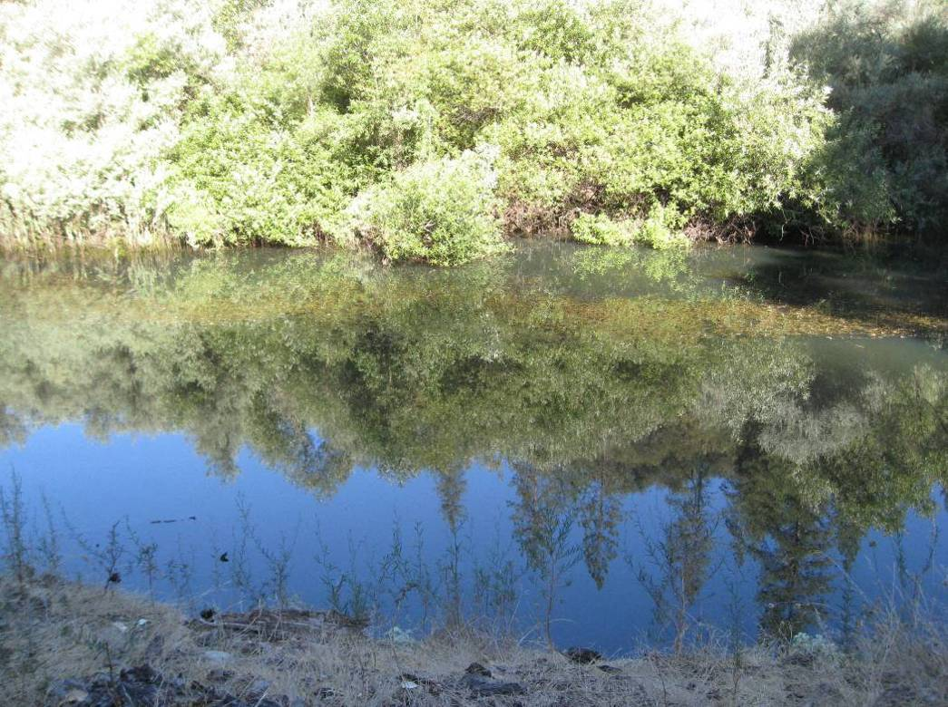

Representative Habitat Photographs at CRLF Survey Ponds

Horseshoe Bar Pond F


